**USC Risk-Score Trend Analysis Methodology**

Kooha Kwon

09/07/2020

**Purpose:**

The purpose of this document is to define and explain methodologies used to categorize LA county regions into three categories: trending up, neutral, trending down.

**Methodology: Moving (Rolling) Average**

As shown in Figure 1, the Risk-Score calculated by USC team showed approximately regular oscillations. The oscillation was not only visible for overall LA county data but also for regional data within LA county. Oscillation increased the variability and makes it difficult to define overall trend of the Risk-Score. In order to reduce variability of the Risk-Score, moving (rolling) average was utilized. Since average oscillation period was around 9 days, moving average period of 18 days was chosen to include two full cycles. With the moving average, the variability of the data is significantly reduced, and overall trend became more visible (figure 2).

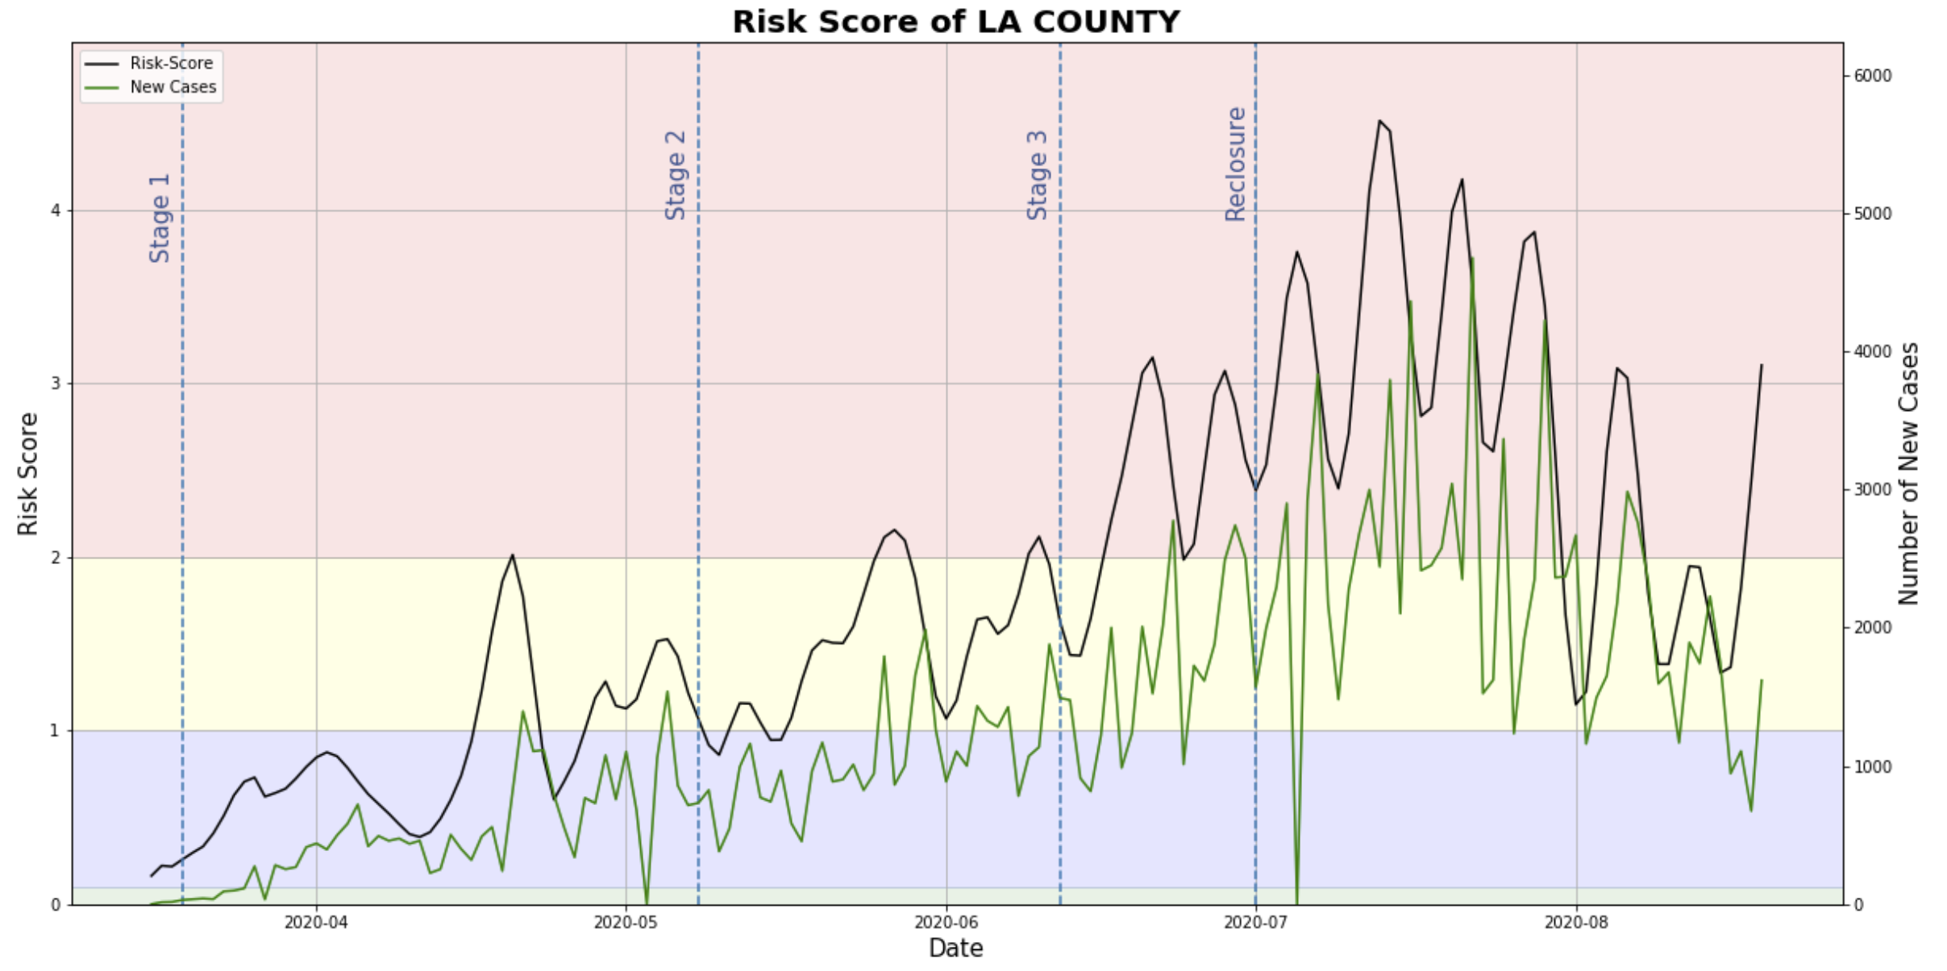

Figure 1: Timeseries plot of LA county Risk-Score shows regular oscillation

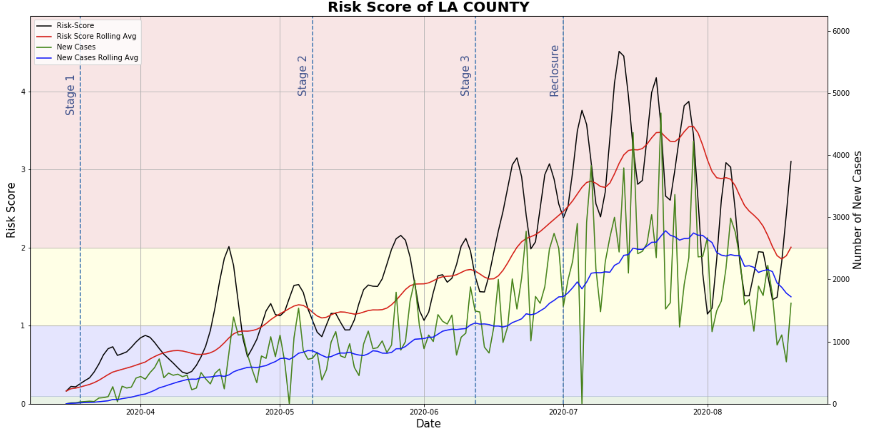

Figure 2: Moving (rolling) average of both Risk-Score and daily new cases data significantly reduces variability.

**Methodology: Trend Categorization**

The daily difference of the moving Risk-Score average was used to determine the Risk-Score trend of individual regions. According to USC’s report, the Risk-Score is the probability of an individual living in a specific region getting infected. Risk-Score of 1 implies a “1 in 10,000 chance of getting infected” and so on. I have defined that there is a significant Risk-Score trend if the Risk-Score increased or decreased by magnitude of 1 within 10-day period. Therefore, the daily difference threshold was set as 1/10 or 0.1.

For example, if Risk-Score of a region increased from 1.0 to 1.2 after a single day, then the daily difference simply calculates to be 0.2. And since the difference is higher than 0.1, the region is defined as “trending up.” The following table defines three trend categories:

|  |  |
| --- | --- |
| Daily Risk-Score Difference | Trend Category |
| Less than -0.1 | Trending Down |
| Between -0.1 and 0.1 | Neutral |
| Greater than 0.1 | Trending Up |

Table 1. Risk-Score Trend Categories

**Conclusion:**

By using those two methodologies, the script effectively defines each LA county regions into three categories. In addition to Risk-Level defined by the USC team, the trend categorization will aid viewers to determine whether a specific region currently has or will have concerning level of Covid-19 risk.